Project Proposal on

**Housing Management System**

By

Samip rai

00164175

Computing Project

Level 5 Diploma in Computing

Softwarica College of IT & E-Commerce

Kathmandu, Nepal

Submission Date: 14 July 2017

Table of Contents

Introduction 1

1.1 Background 1

1.2 Introduction of the Project 1

1.3 Aims 2

1.4 Objectives 2

1.5 Main Features 3

1.6 Development Methodologies 3

Project Plan 4

2.1 Work Breakdown Structure (WBS) and estimated time 4

2.2 Milestone 6

2.3 Scheduling 7

Risk Management 9

Configuration Management 10

Conclusion 11

References 12

# Introduction

## 1.1 Background

Present situation of our country, mostly the city area is extremely overpopulated. From every part of the country, large number of people are being settled inside city area due to various services such as: education, high job opportunity, health, transportation and many more that can get easily and in convenient way. For e.g. teenagers’ search for better education, young and mature person are in search of better job and lifestyle where old people are for better health services. Due to which the population inside city area of country in too populated.

Overpopulation directly affects various factors such as: environment, pollution, food, clothes and places that provide shelter. And it is extremely difficult to find the proper places for person to find the places that is appropriate for them and as they want the places to be. And in daily life each and every day different new houses and buildings are being constructed in various places where the owners are also not satisfied with the paying guests as they rent their room, apartment or house. People are searching room, house, apartment etc. in their daily life according to their choice and location which they have to separate their some part of the time from their busy life searching many places and asking various owner by meeting physically.

Just because of lack of proper method for searching both the owner and paying guests for housing this problem is occurring daily.

So I have decided to develop a housing system that help both the owner and paying guests to find the genuine person suitable for them according to their choice and options.

## 1.2 Introduction of the Project

As my project name implies that it manage the communications between the user and owner of the houses, apartment, colony etc. and help each other to identify and find genuine users based on their data. It is desktop based application that lets the user to create their account, login system, view various other users profile and houses or room that are for rent or sale, search the room for rent or buy based on the details posted by owner, to find the history of both the users and houses and many more and all the data will be stored in the database.

The main purpose behind developing this system is to manage all the houses, room, apartment etc. in such applications based by the data provided by the both the user and owner and helps individually or any organizations related to same field to find trusted users. And to approach the new better and appropriate searching both the user and owner of the houses in an easy and convenient way.

## 1.3 Aims

Some of the major aims that are taken before developing system are as follows:

* To provide the better and efficient way for searching room, apartment, houses individually either by owner for renting or user for paying guests.
* To develop the user friendly desktop application for storing the information provided by the user of it.
* To automate the graphical representation of data such as chart, graphs or reports and calculate the total time and amount for renting and buying room, house or apartments.

## 1.4 Objectives

* To develop the system that can be useful in real life to help the user in their daily activities.
* To explore the knowledge of object-oriented language and database used during development of the system.
* To achieve the aims listed above in a short period of time and in an efficient way.
* To design the system in a more appropriate architecture used in software development industry.
* To document each and every part of the system for future references or any changes in the future and it.
* To implement the system according the design architecture created during early phase of development.
* To test each and every part of system with both black box and white box testing to ensure that it does what it is being developed for with greater usability.

## 1.5 Main Features

* Create account by any user aged above 16 to use application features.
* Login system for authorized users that provide full features of application.
* Create notification and view each notification.
* Able to post for searching rent or paying guests with requirements.
* Search the room, house or apartment for rent or buy based on their choice of location.
* Users can view the records that they like after the permission by the owner.
* Users can follow each users or owner after the permission only.
* Able to update profile and posted data by users.

## 1.6 Development Methodologies

During the development methodology of the system, I have chosen waterfall model as a SDLC (Software Development Lifecycle) while developing it. It is legacy model and suitable to develop the software for small project like mine where all features are specified at early phase before starting developing the system with no any required teamwork. It consists of a detailed plan describing how to develop, maintain, replace and enhance specific feature of software. It aims to produce the high software that meets the requirements of users along with the estimated time and provided cost. (More, 2013)

The major 5 phases used for waterfall model are listed below:

* **Planning and Requirement Analysis:** Both play the most crucial and fundamental stage in waterfall to conduct the feasibility study in every factor which helps for the quality assurance and identify of the risk associated with the system.
* **Design:** Design occurs after all of requirements are collected from and they are addressed and documented. It help developer to create the system layout as well as the other code to create system functionality.
* **Implementation:** The actual development starts and the product is built. The code is generated as per design during this stage. If the design is performed in a detailed and organized manner, code generation can be accomplished in more convenient way.
* **Testing:** Testing activities are mostly involved in all the stages. However, this stage refers to the testing only stage of the product where product defects are reported, tracked, fixed and retested, until the product reaches the quality standards.
* **Deployment and Maintenance:** Once the product is tested and ready to be deployed it is released in the appropriate market. Then based on the feedback provide by user, the product may be released as it is or with suggested enhancements and its maintenance is done for the existing clients base.

While developing the application, I will be using Java for programming because of simple and easy to create desktop based application. And to store the data of user I will use the MySQL database because of its simple and easy to install and handle the table data. Among different architecture I will use MVC design pattern for separating model, view and controller with each other.

# Project Plan

One of the major task to start before any project is to make plan and goals within an estimated planed time. Here I have decided to find out major requirement required for the system and analysis it whether it is feasible or not for it. Then I will design my system making different model for conceptual better and thinking. After it I will implement it to my system and test with various testing method and document for future references and any change in the future.

The tools I have used to create the schedule and Gantt chart is Project Libre because of simple to use and user friendly interface.

## 2.1 Work Breakdown Structure (WBS) and estimated time

Work breakdown structure helps to visualize and defines the scope into manageable chunk that a project can be understood more efficiently its process and can trace the progress of a project.

As in simple, it can be said that it is an outline or map of the particular project. (Work Breakdown Structure)

**WBS:**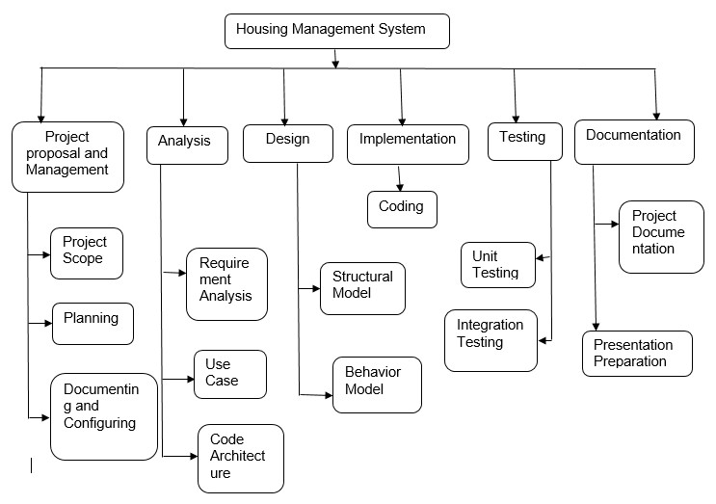

Figure 2.1 - WBS of System

Following provided table is used to estimate the required time to complete the projects:

|  |  |  |
| --- | --- | --- |
| No. | Task Name | Days |
| **1.** | **Project Proposal and Management** |  |
| I. | Project Scope | 5 |
| II. | Planning | 2 |
| III. | Documenting and Controlling | 5 |
|  | Total | 12 |
| **2.** | **Analysis** |  |
| I. | Requirement Analysis | 8 |
| II. | Use Case | 5 |
| III. | Architecture | 5 |
|  | Total | 18 |
| **3** | **Design** |  |
| I. | Structural Model | 11 |
| II. | Behavior Model | 11 |
|  | Total | 22 |
| **4.** | **Implementation** |  |
| I. | Coding | 26 |
|  | Total | 26 |
| **5.** | **Testing** |  |
| i. | Unit Testing | 11 |
| II. | Integration Testing | 11 |
|  | Total | 22 |
| **6.** | **Documentation** |  |
| I. | Main Project Documentation | 10 |
| II. | Presentation Materials | 2 |
|  | Total | 12 |
|  | **Total Days For Project** | **112** |

## 2.2 Milestone

Following list presented in table are the milestone to be achieved:

|  |  |  |
| --- | --- | --- |
| No. | Milestone | Date |
| 1. | Project Proposal | 14th July 2017 |
| 2. | Analysis | 1st August 2017 |
| 3. | Design | 23rd August 2017 |
| 4. | Coding | 17th September 2017 |
| 5. | Testing | 9th October 2017 |
| 6. | Project Completion and Submission | 22nd October 2017 |

## 2.3 Scheduling

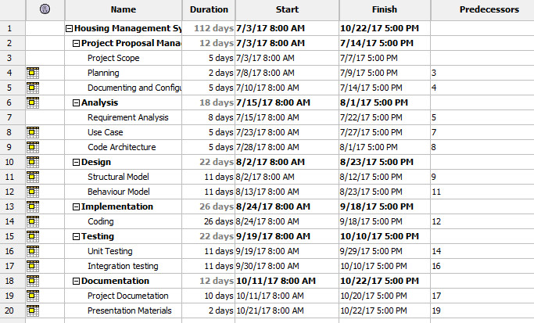

Figure 1.2- Scheduling Time and Date for Project

**Gantt chart**

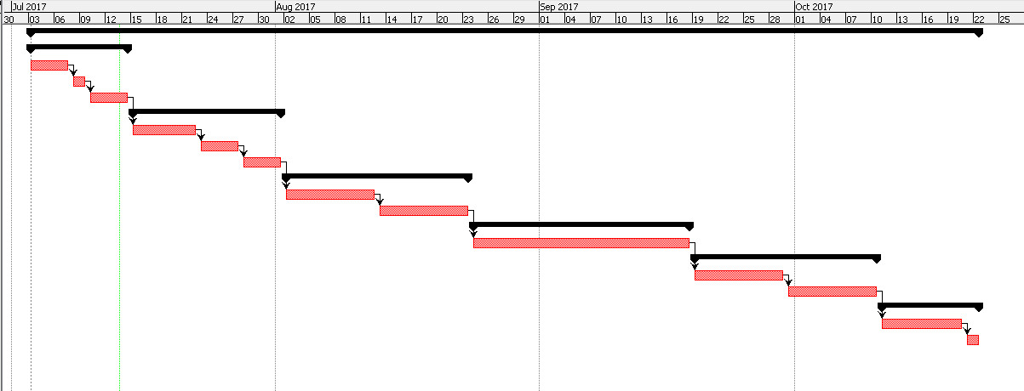

Figure 2.3 - Gantt chart

# Risk Management

For the project management, there may occur any kind of uncertain situation that can be listed in the risk during the project. For e.g. estimation and scheduling exceeds than plan, sudden change in project etc. (Writer, 2010)

Following table provide the visualization of both occurrence and consequence depending on the number value.

|  |  |
| --- | --- |
| **Occurrence** | **Value** |
| Low | 1 |
| Medium | 2 |
| High | 3 |

Fig 3.1: Risk Occurrence value

|  |  |
| --- | --- |
| **Consequence** | **Value** |
| Very Low | 1 |
| Low | 2 |
| Medium | 3 |
| High | 4 |
| Very High | 5 |

Fig 3.2: Risk Consequence value

Following are the list of risk that may occur and the impact of it towards our project i.e.

*Impact = risk occurrence * consequence.*

|  |  |  |  |  |
| --- | --- | --- | --- | --- |
| **Risk Name** | **Occurrence** | **Consequence** | **Impact** | **Action** |
| Electricity Cut | 3 | 3 | 9 | Use of solar or backup power |
| Manpower sick | 2 | 4 | 8 | Taking rest and proper medicine to recovery. |
| Exceeds deadline of time as we planned earlier | 1 | 5 | 5 | Providing extra time for project that don’t cross deadline |
| Natural disaster (fire, earthquake etc.) | 1 | 5 | 5 | Back up of data in various places such as cloud. |
| Data Theft | 2 | 3 | 6 | Personal information should be kept separately and safe. |
| Hard disk crash | 2 | 4 | 8 | Back up data daily. |

In the above table we have listed all the risk with its occurrence, consequence, impact on our project and action that can solved the risk. It is very necessary to identify all the risk that could take during project so we can take an action to solve it to finish our project on time with no interfere which is also a part of managing project.

# Configuration Management

It is difficult to manage the files if all files are scattered in different drive and folders. So to manage locally all files, I will create a new folder named with relevant words which will also contain subfolders depending on the files that will be used during project development. Following is an image of folders for managing all files locally.

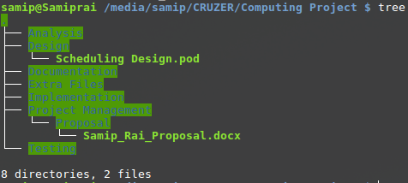

Fig 4 -Managing Folders and Files

It is too difficult to trace any changes in the file that are stored locally or either need to create same file with appropriate name to trace any changes within the content.

I will be using free services provided by Git i.e. GitHub ([GitHub](https://github.com/)) with a public repository for version controlling and tracking any changes and also it will be a backup file too in case files gets corrupted or deleted mistakenly. (Finley, 2012)

# Conclusion

In the current situation to find the room, house in sale, flat, apartment etc. is too difficult based on their requirements so, the aim of my application is to help them user to find it as their requirements.

Here I have included my purpose of doing project, planning and scheduling for the project along with Work Breakdown Structure (WBS) and Gantt chart to track progress and scheduling. The application is supposed to be user friendly and easy to use and try to provide efficient result to users. Risk identifying is also included in an early stage. If any of them occur so we can submit our project on time by eliminating such risk with certain action related to it. Configuration of files and folders are also done in web services provided by GitHub that helps to trace any changes along with collaboration with anyone if they want.

Hence, I have planned my project in an efficient way to finish and submit my project on time containing all the features, aim and goals listed above so, the user of my application can make their life better.

# References

Finley, K. (2012, July 14). *Tech Crunch*. Retrieved from What Exactly Is GitHub Anyway?: https://techcrunch.com/2012/07/14/what-exactly-is-github-anyway/

More, P. (2013, April 9). *Why SDLC is important to your business*. Retrieved from Blog of Dell: https://blog.dell.com/en-us/why-sdlc-is-important-to-your-business/

*Tutorialspoint*. (n.d.). Retrieved from SDLC - Overview: https://www.tutorialspoint.com/sdlc/sdlc_overview.htm

*Work Breakdown Structure*. (n.d.). Retrieved from Workbreakdownstructure.com: https://www.workbreakdownstructure.com/

Writer, S. (2010, June 10). Retrieved from Top 10 Software Development Risks: http://www.itproportal.com/2010/06/14/top-ten-software-development-risks/